Title: Temporal Awareness and Personal Presence: A Transdisciplinary Exploration of Consciousness Across Time
Dr. Keyaunoosh Kassauei, MD; Joel Bennett, PhD, CWP; Robert Wilkinson
Corresponding Author: Joel Bennett, owls@organizationalwellness.com; 817-845-2772
Proposal Narrative: The science of temporality is emerging as a central frontier in consciousness studies. Time is not only a physical dimension—it is a psychological, cultural, neurological, social, and even cosmological phenomenon. This experiential workshop invites participants to explore PERSONAL PRESENCE as a core expression of human temporality, drawing on perspectives spanning the scientific, symbolic, and transpersonal.
Temporality shapes consciousness at multiple levels: the immediacy of lived experience, the narrative arc of a human life, and the vast patterns that connect individual awareness to the cosmos. To illuminate these layers, each presenter introduces a distinct scientific lens on time and guides participants through an experiential practice that grounds the theory in direct personal insight.
The workshop unfolds through three complementary perspectives, each supported by substantive bodies of qualitative or quantitative research (sample citations provided):
- Near-Death Experience Research A scientific examination of altered temporality during near-death states—where time may dilate, collapse, or disappear entirely (e.g., Kayış 2026; Lake, 2017; Wittmann, 2018). Participants engage in a contemplative exercise to explore their own boundaries of presence and temporal perception.
- Post-Modern Astrology and Human Life Stages A developmental and cosmological framework that interprets human life cycles as patterned expressions of larger cosmic rhythms (e.g., Currey, 2023; LeGrice, 2011; Shahannaz, 2026) Participants use reflective self-assessment to map their current life stage within broader temporal archetypes.
- Psychospiritual Narrative and Psychological Time Perspective Drawing on Zimbardo’s time-perspective theory and contemporary cosmology, this segment explores how personal narratives shape—and are shaped by—our orientation toward past, present, and future. Participants engage in journaling or active listening to deepen awareness of their temporal biases.
Each segment includes paired dialogue and whole-group discussion to integrate insights and highlight cross-disciplinary connections. The workshop culminates in a synthesized model of temporal consciousness, co-constructed with participants, demonstrating how these three perspectives converge to illuminate personal presence as both a psychological skill and a cosmological phenomenon.
The presenters have each presented and/or written about these perspectives, including:
Wilkinson, R. (2025) The Cycles of Life: Seven Year Cycles and Stages of Change.
Kassauei, K. (2025). A Doctor's Near-Death Experience During Surgery (podcast)
Bennett, J. (2022-2025). Quest for Presence Book Collection.
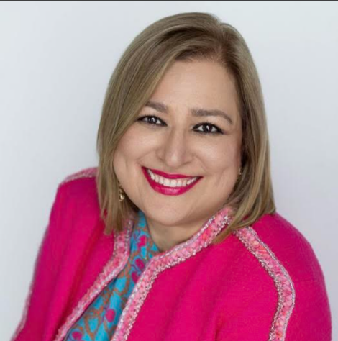
Dr. Keyaunoosh Kassauei MD
Dr. Keyaunoosh Kassauei MD is an international medical graduate (IMG). She continued her medical education with a post-doctoral research fellowship at JHU/SOM (The Johns Hopkins Hospital, School of Medicine) in the United States. Her respected work during her pathology fellowship at Hopkins in the study of mitochondrial DNA mutations in pancreatic cancer patients has led to several publications in prominent journals of medicine like Nature. Enlightened by her NDE (Near Death Experience in 2006), she developed a passion for coaching in Healthcare & Leadership and founded MCCG (My conscious coaching group, as a 501C3 coaching nonprofit in 2018) with a mission to heal and care for the Whole-Self and a vision to raise self and global awareness for a conscious mind through education and application of EQ/SQ (Emotional Intelligence and Spiritual/Deep intelligence) for our humanity and all earth citizens.
Keyaunoosh is an EICC Meta Coach (Emotional Intelligence Certified Meta Coach) from Goleman ei & Beyond ei) with a focus on coaching physicians & leaders in the healthcare & education space. She started her education with CME certifications at IOC/HMS (Institute of Coaching at Harvard Medical School/McLean) since 2010, and subsequently as an affiliate and currently a Professional Fellow at of IOC/HMS who serves on the board of REI Council (Race, Equity and Inclusion) as well, and is a contributor to IOC white papers, Blogs, Coaching Huddles & conference as facilitator.
She has been a member of ICF& ICF Foundation (International Coach Federation) since 2020.
As founder of Conscious Coaching and their Education initiatives, Keyaunoosh hosts a podcast (link below) and is a radio speaker at iHeart/Business Talk Radio, and IANDS Radio. She is coauthor of International Best Seller, “Beautiful Scars”
Website: https://myconscious.org/

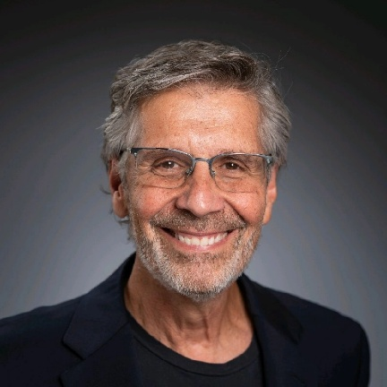
Joel B. Bennett, PhD
Joel Bennett (Ph.D., CWP, Certified Health & Wellness Coach) is President of Organizational Wellness & Learning Systems (OWLS), a consulting firm specializing in evidence-based wellness technologies to promote psychological and spiritual presence, organizational health and employee well-being. Dr. Bennett first delivered stress management programming in 1985, and OWLS programs have since reached nearly 250,000 workers across the United States and abroad, including training over 1,000 facilitators and coaches. He is a primary developer of “Team Awareness” and “Team Resilience,” evidence-based culture of health programs recognized by the U.S. Dept. of Health and Surgeon General as effective in reducing employee behavioral risks. In 2022, Dr. Bennett was acknowledged with the "Lifetime Achievement Award" from the National Wellness Institute and, internationally, with the "Positive Leadership Award" from the Positive Leadership Institute.
He earned his Bachelor’s Degree in Psychology and Philosophy from the State University of New York (Purchase) and his MA and PhD in Psychology from the University of Texas-Austin. Dr. Bennett has authored/co-authored nine books, including "Raw Coping Power," "Heart-Centered Leadership," and "Your Best Self at Work," and his Google Scholar page provide links to over 30 peer-reviewed scientific studies.
Dr. Bennett's favorite topic is mysticism and the re-awakening of humanity through presence. His five book “Quest for Presence” series is a multi-part guide to living a more meaningful life by re-imagining one's relationship with time. It helps readers shift from a focus on "clock time" (management) to "deep time" (experience), using a mix of science, philosophy, and exercises to cultivate presence and well-being. Key concepts include a "Time Adjustment Protocol" to make the most of each moment, developing "Soulful Capacities" like acceptance and flow, and embracing personal attractions and potential.
Website: www.presencequest.life

Robert Wilkinson
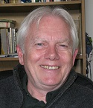
Robert Wilkinson has been an internationally-known metaphysician, astrologer, and counselor for over 50 years. His work explains the intersections of time, evolution, and movements in consciousness of individuals as they adjust to new perceptions at crucial and predictable moments of life. Having had an NDE in 1984 after a catastrophic accident, he has directly experienced consciousness as our eternal state as we move through our cycles of various levels and dimensions of human experience.
He is the author of seven books, including “The Cycles of Life: Seven Year Cycles and Stages of Change,” “Saturn: Spiritual Master, Spiritual Friend,” and “Love Dad: Healing the Grief of Losing a Stillborn.” Robert Wilkinson has a wide perspective about the changing times in the astrological community with regard to how Astrology has evolved as a divine science of our daily lives. Robert Wilkinson has published more than 6000 articles (previously on www.aquariuspapers.com and now being archived). He writes educative articles on some important transits that are taking place in the sky that carry deeper spiritual and psychological meanings with the right amount of spiritual touch.
Robert’s website is https://aquariuspapers.substack.com/

